**Object Oriented Development**

Module 8 : Static Keyword

© FDM Group Ltd 2020. All Rights Reserved.

Any unauthorised reproduction or distribution in part  
or in whole will constitute an infringement of copyright.

|  |  |  |  |
| --- | --- | --- | --- |
| Version | Date | Author | Comments |
| 1.0 | 3 / 11 / 20 | Nick Lawton | First draft |
|  |  |  |  |
|  |  |  |  |
|  |  |  |  |
|  |  |  |  |
|  |  |  |  |

## Part 1 – Creating a utility class

Create a packaged called com.fdmgroup.staticKeywordExercises

In this exercise, you’re going to create a utility class which uses Einstein’s famous formula E = MC2 to convert energy to matter and matter to energy.

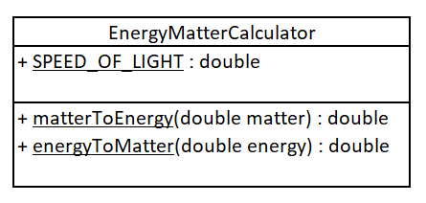

1. Create the class in the UML above.
   1. The speed of light is 299792458 metres per second.
   2. The matter to energy formula is E = MC2
   3. The energy to matter formula is M = E / C2
2. Create a class called Runner with a main method.
   1. In the main method call both methods directly from the class (do not create an object of EnergyMatterCalculator). Verify that they produce the correct values.

## Part 2 – Creating a class with a static variable

1. Create the class in the UML below:

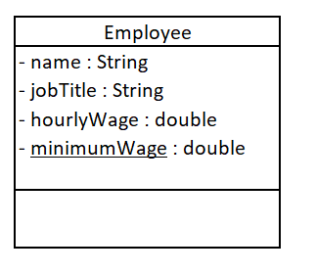

1. Create getters and setters for all variables.
2. Modify the setHourlyWage() method so that if its argument is below the minimum wage, the hourly wage is defaulted to being the same as the minimum wage.
3. Create a class called Runner with a main method.
4. In the main method call the setMinimumWage method directly from the class and pass in a value of 9.53.
5. Create 3 employee objects.
6. Call the setHourlyWage method on all 3 employee objects. For the first 2 objects, pass in values less than the minimum wage. For the 3rd object pass in a value above the minimum wage.
7. Call the getHourlyWage on all 3 employee objects. Verify that the first 2 are being paid the minimum wage and that the 3rd is being paid above the minimum wage.